NAME : MUHAMMAD FAIZAN AKBAR
ROLL NUMBER : L1F23BSCS0277
SECTION : E-14

LAB – 8

Task 1 :
#include <stdio.h>
#include <stdlib.h>
#include <pthread.h>

int *numbers;
int count;

double average = 0;
int minimum = 0;
int maximum = 0;

void *calc_average(void *arg) {
double sum = 0;
for (int i = 0; i < count; i++) {
sum += numbers[i];
}
average = sum / count;
pthread_exit(NULL);
}

void *calc_minimum(void *arg) {
int min = numbers[0];
for (int i = 1; i < count; i++) {
if (numbers[i] < min)
min = numbers[i];
}
minimum = min;
pthread_exit(NULL);
}

void *calc_maximum(void *arg) {
int max = numbers[0];
for (int i = 1; i < count; i++) {
if (numbers[i] > max)
max = numbers[i];
}
maximum = max;
pthread_exit(NULL);
}

int main(int argc, char *argv[]) {
if (argc < 2) {
printf("Usage: %s num1 num2 num3 ...\n", argv[0]);
return 1;
}

count = argc - 1;
numbers = malloc(sizeof(int) * count);

for (int i = 1; i < argc; i++) {
numbers[i - 1] = atoi(argv[i]);
}

pthread_t tid1, tid2, tid3;

pthread_create(&tid1, NULL, calc_average, NULL);
pthread_create(&tid2, NULL, calc_minimum, NULL);
pthread_create(&tid3, NULL, calc_maximum, NULL);

pthread_join(tid1, NULL);
pthread_join(tid2, NULL);
pthread_join(tid3, NULL);

printf("The average value is %.0f\n", average);
printf("The minimum value is %d\n", minimum);
printf("The maximum value is %d\n", maximum);

free(numbers);
return 0;
}
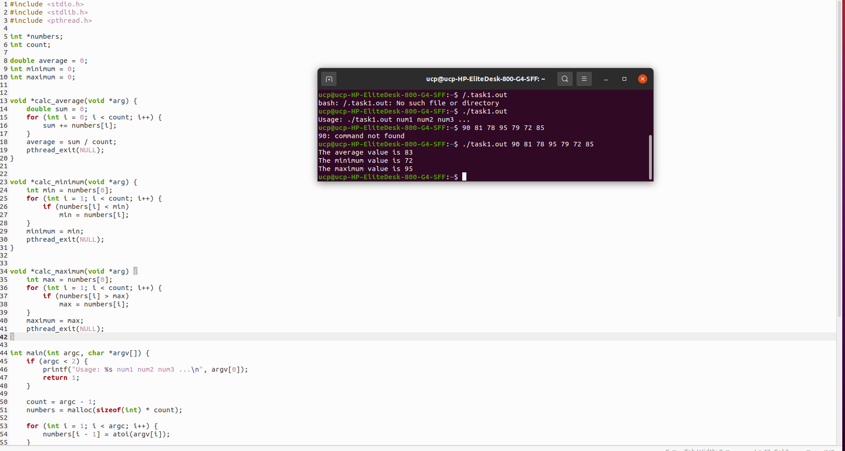
Task 2 :
#include <stdio.h>
#include <stdlib.h>
#include <pthread.h>

long long n;
int num_threads;
double pi_sum = 0.0;
pthread_mutex_t lock;

void* compute_pi(void* rank) {
long thread_id = (long) rank;

long long terms_per_thread = n / num_threads;
long long start = thread_id * terms_per_thread;
long long end = start + terms_per_thread;

double partial_sum = 0.0;

for (long long k = start; k < end; k++) {
double term = ((k % 2 == 0) ? 1.0 : -1.0) / (2 * k + 1);
partial_sum += term;
}

pthread_mutex_lock(&lock);
pi_sum += partial_sum;
pthread_mutex_unlock(&lock);

return NULL;
}

int main(int argc, char* argv[]) {
if (argc != 3) {
printf("Usage: %s <number of threads> <n>\n", argv[0]);
return 1;
}

num_threads = atoi(argv[1]);
n = atoll(argv[2]);

if (n < 100000 || n % num_threads != 0) {
printf("Error: n must be > 100000 and divisible by number of threads.\n");
return 1;
}

pthread_t* threads = malloc(num_threads * sizeof(pthread_t));
pthread_mutex_init(&lock, NULL);

for (long t = 0; t < num_threads; t++) {
pthread_create(&threads[t], NULL, compute_pi, (void*) t);
}

for (int t = 0; t < num_threads; t++) {
pthread_join(threads[t], NULL);
}

double pi = 4.0 * pi_sum;
printf("Estimated pi = %.15f\n", pi);

pthread_mutex_destroy(&lock);
free(threads);

return 0;
}

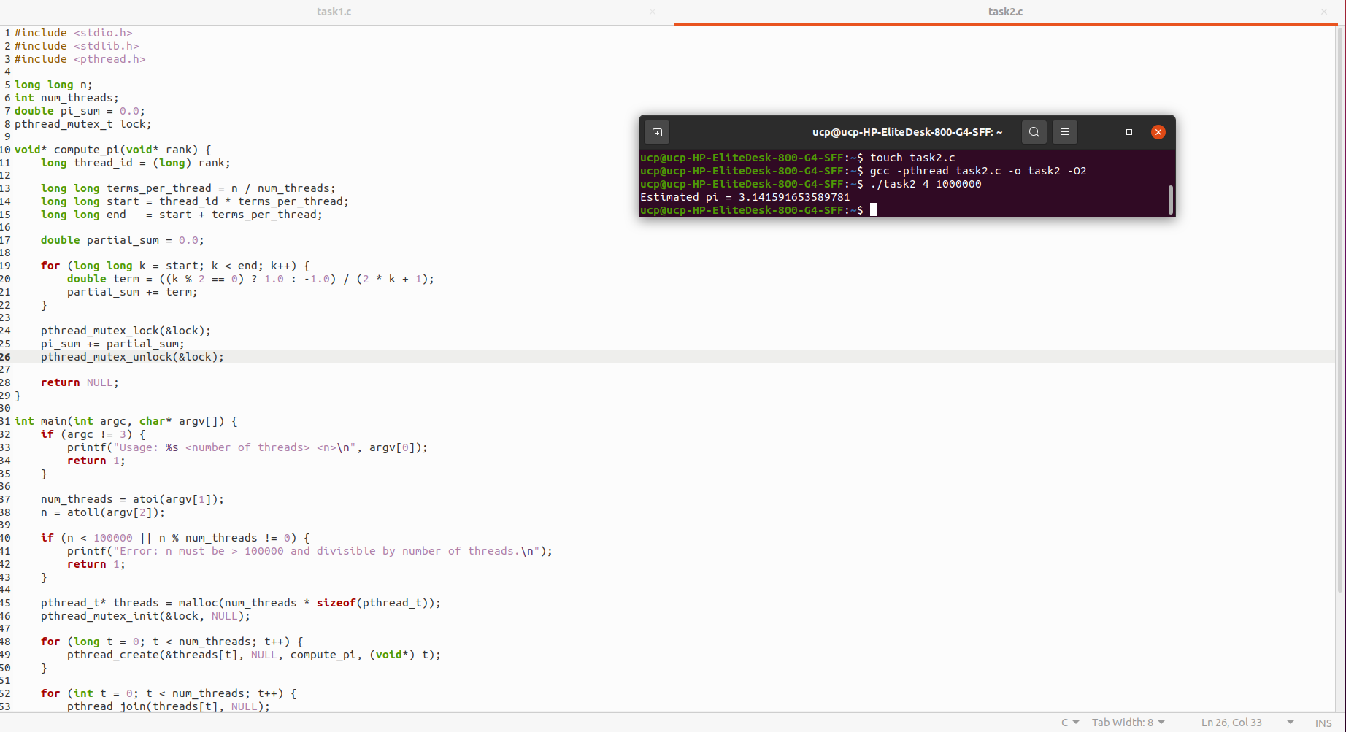
Task 3 :
#include <stdio.h>
#include <stdlib.h>
#include <string.h>
#include <pthread.h>

char **lines;
long total_lines;
char *target;
int found = 0;
pthread_mutex_t lock;

typedef struct {
long start;
long end;
} ThreadRange;

void* search(void *arg) {
ThreadRange *r = (ThreadRange*) arg;

for (long i = r->start; i < r->end && !found; i++) {
char *p = strstr(lines[i], target);
if (p) {
pthread_mutex_lock(&lock);
if (!found) {
found = 1;
long col = p - lines[i] + 1;
printf("Found at line %ld, column %ld\n", i + 1, col);
}
pthread_mutex_unlock(&lock);
return NULL;
}
}
return NULL;
}

int main(int argc, char *argv[]) {
if (argc != 4) {
printf("Usage: %s <filename> <threads> <string>\n", argv[0]);
return 1;
}

char *filename = argv[1];
int num_threads = atoi(argv[2]);
target = argv[3];

FILE *f = fopen(filename, "r");
if (!f) {
printf("File cannot be opened.\n");
return 1;
}

lines = malloc(sizeof(char*) * 1000000);
char buffer[2048];
total_lines = 0;

while (fgets(buffer, sizeof(buffer), f)) {
lines[total_lines] = strdup(buffer);
total_lines++;
}
fclose(f);

pthread_t threads[num_threads];
pthread_mutex_init(&lock, NULL);

long chunk = total_lines / num_threads;

for (long t = 0; t < num_threads; t++) {
ThreadRange *r = malloc(sizeof(ThreadRange));
r->start = t * chunk;
r->end = (t == num_threads - 1) ? total_lines : r->start + chunk;
pthread_create(&threads[t], NULL, search, r);
}

for (int t = 0; t < num_threads; t++) {
pthread_join(threads[t], NULL);
}

if (!found) printf("String not found.\n");

for (long i = 0; i < total_lines; i++) free(lines[i]);
free(lines);
pthread_mutex_destroy(&lock);

return 0;
}
